The Journey of Holiness
September 9, 2016
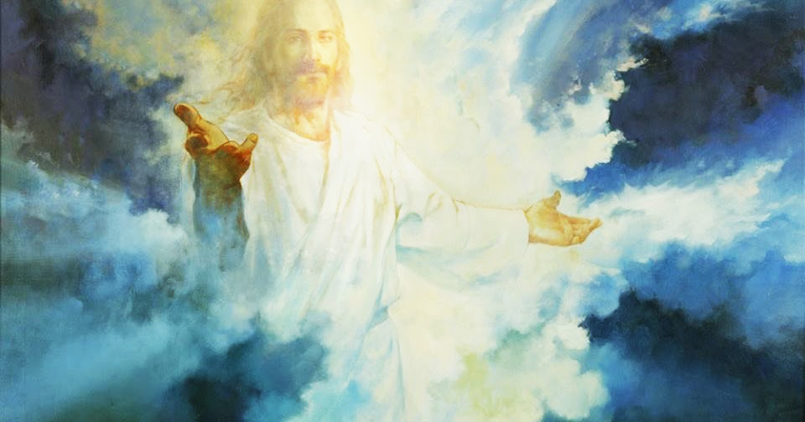
Well, my dearest Heartdwellers, we came under attack today, with new weapons of destruction sent by the enemy. Something we'd never experienced before, and for a while there it was difficult. But I am coming to learn that though we be alone, (in the sense that Ezekiel and I were outnumbered) no matter the odds against us, there are five present - and three of them are the Godhead. And Satan cannot win any fight against the Father, Son, and Holy Spirit. And one little believer - no matter how puny - still outnumbers legions of the enemy when God is present and fighting for them. But we do not rejoice that the demons are subject to us, but that our names are written in the book of life.

As it is written: See, I have given you authority to tread on snakes and scorpions, and over all the power of the enemy. Nothing will harm you. Nevertheless, do not rejoice that the spirits submit to you, but rejoice that your names are written in Heaven. Luke 10:19-20

No matter how difficult the opposition, Heartdwellers, God will not permit you to be tried beyond your strength. Stand still and see the glorious salvation of God!

Even as Moses said to the people, "Do not fear! Stand by and see the salvation of the LORD which He will accomplish for you today; for the Egyptians whom you have seen today, you will never see them again. The LORD will fight for you while you keep silent.”…Exodus 14:13:14

"Clare, I only do what is necessary, to bring all of you around to a new holiness of life. The Fear of God is the beginning of Wisdom. I take My role as God very seriously. When a soul cries out to Me to become holy, consistently, I take them at their word and do whatever is necessary to bring them into that happy estate.

"Yes, it is a happy estate. It is a place of rest from striving, contamination, with a pure conscience. One that can shoulder the gift of the cross imparted to them, without complaint. There is nothing more beautiful, more exquisite to behold than a holy soul.

"But getting there is an arduous journey and most stop only half-way. I am calling you all to go the full nine yards with Me. Nothing in this world is worth having more than Me! And next after that, is a pure and holy conscience which is not troubled by sin.

"A soul who has chosen the vocation of holiness cannot afford to have any attachments but Me. Yes, love for his neighbor; but preferences, opinions, wants, must all be aligned with what I am doing in their lives."

Jesus, I recognize that I have a terribly long way to go.

"This is true, but consider: you have chosen to be on the way. You have chosen to stay on the way and that means everything to Me. Most souls quit very early on the path, because the world’s agenda pulls them away from Me. They are not taught as young children the things that are most important. Rather, they are pulled in every other direction: competition, popularity, affluence, power and prowess, beauty. All this, all these values are worked into children very early in life as they observe their parents, who very often lead them in the paths they wanted for their own lives, but failed to succeed at.

"So, to have a soul ready to give up everything for My sake is a rare gift. I take them at their word and though they have no idea of the cost involved, I lead them steadily up the mountain, sometimes even carrying them. But there are junctures of reassessment. Times when the temptation to quit becomes very attractive, because what is being asked of them is beyond what they are willing to give. Holding onto some fancy or idea brings Me to a point where I must find another way to coax them to keep climbing. I do this, because I love you so much. I know what you want at the end of your life and I want you to have it. So, I find ways to get you beyond your protests and keep you climbing. It isn’t easy, but it’s rewarding. And nothing that is sacrificed is regretted at the end of your journey.

"So, for you right now, we are still climbing the mountain of brotherly love and learning to trust and yield to Me in the journey. I am constantly expanding your faith and trust in Me. I know what you long for, Clare. I know your reluctance, and I know you will yield.

"Human nature is an inexplicable and inexhaustible well of conflicting emotions and thoughts competing for dominance in your life. Yet, when I take over, I sort these out and make them work to the soul’s advantage.

"I have imparted so many dormant gifts to the soul at the beginning of their journey, they have no idea the wonder of what lies hidden inside of them. Yet, it is My part to reveal to them and motivate them to pick up the tools. But first, I must strengthen their frame, their moral and ethical frame, their love for Me and for others, before I release them into their gifts.

"It’s a tempering process and requires many trips through fire and ice. Yet the souls that say 'yes' at every juncture of the journey, at the end, shine like diamonds illuminating a murky, grey world; bringing hope, inspiration and a vision of Heaven because they are a likeness of Me.

"It is a vastly immense concept. Only those who have graduated truly understand the journey. When you are in the midst of it you can’t see more than a few feet ahead of you. But at the end, you see from My perspective and the brilliant light you’ve shed from your earthly light.

"And that light never goes out. It serves as a beacon to all who are searching for the Truth. That is truly what I am calling you to be. Your accomplishments working with Me are secondary. What is truly important was the character of your life. Not what you did, but who you became when you died to yourself.

"So, My dear ones, I know this is difficult for you to grasp. All I can promise you is supreme happiness and fulfillment at the end of the journey. You have My word on it. If you die in Me, you will be raised to eternal life with Me."

And that reminded me of a Scripture:

11If we died with him, we will also live with him 12if we endure, we will also reign with him.10Therefore I endure everything for the sake of the elect, that they too may obtain the salvation that is in Christ Jesus, with eternal glory. 2Timothy 2

